Limelight’s application group’s

*** Happy Path

|  |  |  |  |  |  |  |  |  |
| --- | --- | --- | --- | --- | --- | --- | --- | --- |
| Test Scenario Id | Test Case Id | Test Case Description | Preconditions | Steps | Inputs | Expected Result | Actual Result | Pass/Fail |
| Save-Group | Save-Group-1 | Save-Group All the mandatory fields captured and the optional | - The user must all ready enter to the module New Group Setup | 1.- Enter correct Company Name  2.- Enter correct Zip Code  3.- The Country field autocomplete with the zip code reference  4.- Enter valid SIC  5.- Select an option from the list  6.- Select Group Type Prospect  7.- Select yes NumEmployees  8.- Click Save & Continue | CompanyName=My company  ZipCode=90011  Country=USA  SICInput=800  SICSelected=FORESTRY  GroupType=Prospect  NumEmployees=Yes | Button Save & Continue redirect to the page(www.limelighthealth.com/nextPage) | As expected | pass |

|  |  |  |  |  |  |  |  |  |
| --- | --- | --- | --- | --- | --- | --- | --- | --- |
| Test Scenario Id | Test Case Id | Test Case Description | Preconditions | Steps | Inputs | Expected Result | Actual Result | Pass/Fail |
| Save-Group | Save-Group-2 | Save-Group All the mandatory fields captured but not the optional | - The user must all ready enter to the module New Group Setup | 1.- Enter correct Company Name  2.- Enter correct Zip Code  3.- The Country field autocomplete with the zip code reference  4.- Enter valid SIC  5.- Select an option from the list  6.- Select Group Type Prospect  7.- Select yes NumEmployees  8.- Click Save & Continue | CompanyName=My company  ZipCode=90011  Country=USA  SICInput=Null  SICSelected=Null  GroupType=Prospect  NumEmployees=Yes | Button Save & Continue redirect to the page(www.limelighthealth.com/nextPage) | As expected | pass |

*** Test Case’s that not follow the happy path

*This Test Case apply for any mandatory field

|  |  |  |  |  |  |  |  |  |
| --- | --- | --- | --- | --- | --- | --- | --- | --- |
| Test Scenario Id | Test Case Id | Test Case Description | Preconditions | Steps | Inputs | Expected Result | Actual Result | Pass/Fail |
| Save-Group | Save-Group-3 | Save-Group The user capture the form but ignore some mandatory field | - The user must all ready enter to the module New Group Setup | 1.- Did not capture Company Name  2.- Enter correct Zip Code  3.- The Country field autocomplete with the zip code reference  4.- Enter valid SIC  5.- Select an option from the list  6.- Select Group Type Prospect  7.- Select yes NumEmployees  8.- Click Save & Continue | CompanyName=Null  ZipCode=90011  Country=USA  SICInput=800  SICSelected=FORESTRY  GroupType=Prospect  NumEmployees=Yes | The button Save & Continue are disabled and must not redirect | The button Save & Continue are disabled and did not redirect | pass |

|  |  |  |  |  |  |  |  |  |
| --- | --- | --- | --- | --- | --- | --- | --- | --- |
| Test Scenario Id | Test Case Id | Test Case Description | Preconditions | Steps | Inputs | Expected Result | Actual Result | Pass/Fail |
| Save-Group | Save-Group-4 | Save-Group The user capture all the form but the length of Company Name is not correct | - The user must all ready enter to the module New Group Setup | 1.- Enter Company Name  2.- Enter correct Zip Code  3.- The Country field autocomplete with the zip code reference  4.- Enter valid SIC  5.- Select an option from the list  6.- Select Group Type Prospect  7.- Select yes NumEmployees  8.- Click Save & Continue | CompanyName=Li  ZipCode=90011  Country=USA  SICInput=800  SICSelected=FORESTRY  GroupType=Prospect  NumEmployees=Yes | Button Save & Continue redirect to the page(www.limelighthealth.com/nextPage) | The button Save & Continue are available but the user get the message “The Company Name length must be between 3 and 50 character’s” | fail |

|  |  |  |  |  |  |  |  |  |
| --- | --- | --- | --- | --- | --- | --- | --- | --- |
| Test Scenario Id | Test Case Id | Test Case Description | Preconditions | Steps | Inputs | Expected Result | Actual Result | Pass/Fail |
| Save-Group | Save-Group-5 | Save-Group The user capture all the form but the length of Zip Code is not correct | - The user must all ready enter to the module New Group Setup | 1.- Enter Company Name  2.- Enter incorrect Zip Code  3.- The Country field autocomplete with the zip code reference  4.- Enter valid SIC  5.- Select an option from the list  6.- Select Group Type Prospect  7.- Select yes NumEmployees  8.- Click Save & Continue | CompanyName=Limelight  ZipCode=90011  Country=USA  SICInput=800  SICSelected=FORESTRY  GroupType=Prospect  NumEmployees=Yes | Button Save & Continue redirect to the page(www.limelighthealth.com/nextPage) | The button Save & Continue are available but the user get the message “The ZipCode length must be between 5 and 6 digits” | fail |

|  |  |  |  |  |  |  |  |  |
| --- | --- | --- | --- | --- | --- | --- | --- | --- |
| Test Scenario Id | Test Case Id | Test Case Description | Preconditions | Steps | Inputs | Expected Result | Actual Result | Pass/Fail |
| Save-Group | Save-Group-6 | Save-Group The user capture all the form but in the Zip Code capture letter’s | - The user must all ready enter to the module New Group Setup | 1.- Enter Company Name  2.- Enter incorrect Zip Code  3.- The Country field autocomplete with the zip code reference  4.- Enter valid SIC  5.- Select an option from the list  6.- Select Group Type Prospect  7.- Select yes NumEmployees  8.- Click Save & Continue | CompanyName=Limelight  ZipCode=9001A  Country=USA  SICInput=800  SICSelected=FORESTRY  GroupType=Prospect  NumEmployees=Yes | Button Save & Continue redirect to the page(www.limelighthealth.com/nextPage) | The button Save & Continue are available but the user get the message “The ZipCode must have only digits” | fail |

|  |  |  |  |  |  |  |  |  |
| --- | --- | --- | --- | --- | --- | --- | --- | --- |
| Test Scenario Id | Test Case Id | Test Case Description | Preconditions | Steps | Inputs | Expected Result | Actual Result | Pass/Fail |
| Save-Group | Save-Group-7 | Save-Group The user capture all the form but in the Country field capture numbers | - The user must all ready enter to the module New Group Setup | 1.- Enter Company Name  2.- Enter Zip Code  3.- Capture the Country field with numbers  4.- Enter valid SIC  5.- Select an option from the list  6.- Select Group Type Prospect  7.- Select yes NumEmployees  8.- Click Save & Continue | CompanyName=Limelight  ZipCode=90011  Country=USA123  SICInput=800  SICSelected=FORESTRY  GroupType=Prospect  NumEmployees=Yes | Button Save & Continue redirect to the page(www.limelighthealth.com/nextPage) | The button Save & Continue are available but the user get the message “The Country must have only letters” | fail |

|  |  |  |  |  |  |  |  |  |
| --- | --- | --- | --- | --- | --- | --- | --- | --- |
| Test Scenario Id | Test Case Id | Test Case Description | Preconditions | Steps | Inputs | Expected Result | Actual Result | Pass/Fail |
| Save-Group | Save-Group-8 | Save-Group The user capture all the form but not select the SIC from the dropdown | - The user must all ready enter to the module New Group Setup | 1.- Enter correct Company Name  2.- Enter correct Zip Code  3.- The Country field autocomplete with the zip code reference  4.- Enter valid SIC  5.- Not select an option from the list  6.- Select Group Type Prospect  7.- Select yes NumEmployees  8.- Click Save & Continue | CompanyName=My company  ZipCode=90011  Country=USA  SICInput=800  SICSelected=Null  GroupType=Prospect  NumEmployees=Yes | Button Save & Continue redirect to the page([www.limelighthealth.com/nextPage](http://www.limelighthealth.com/nextPage)) but without saving the SIC field | As expected | pass |

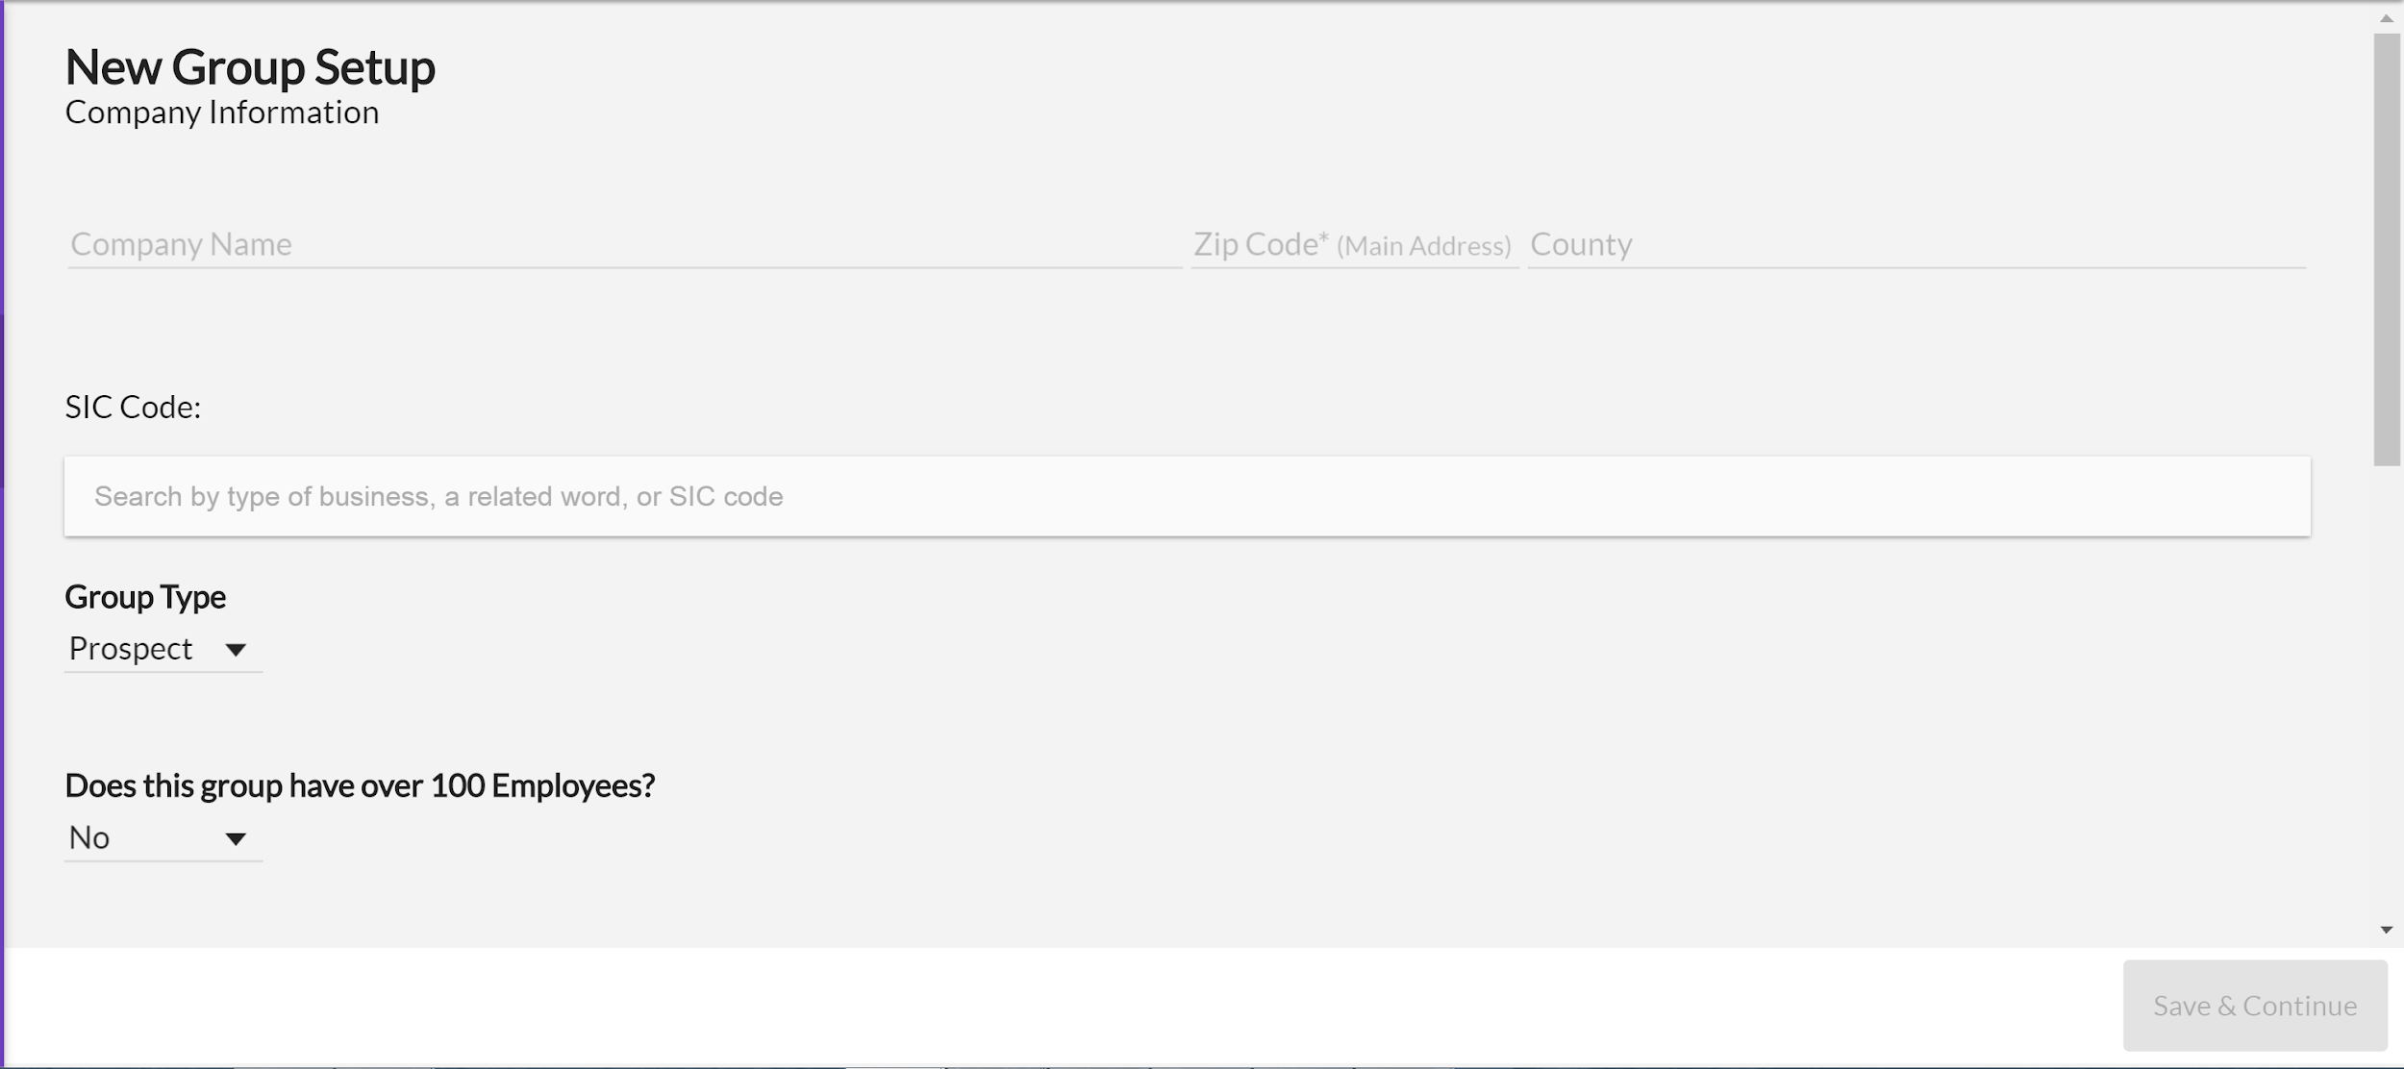

Diseño del dropdown

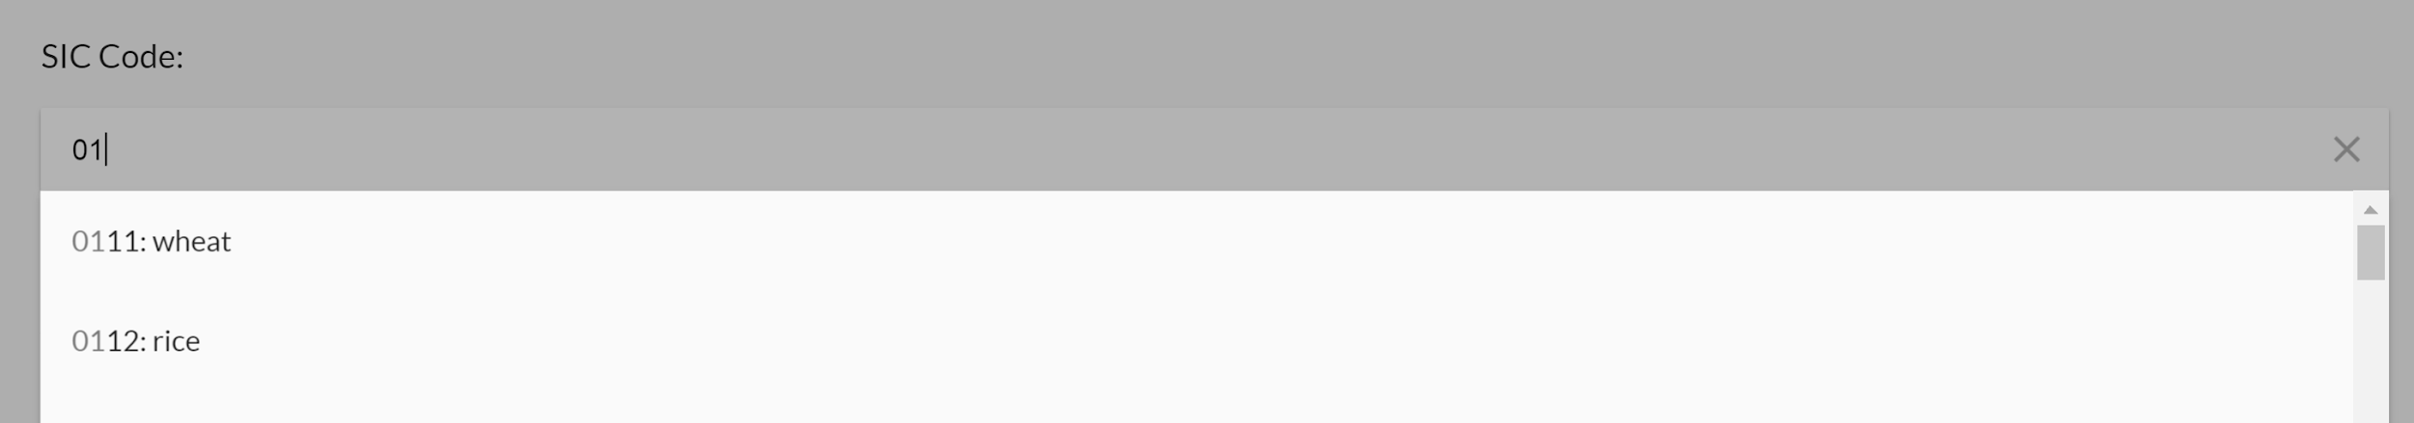

**Time Estimate:**

**Q1. 60 Minutes**

**Q1.** Given the following feature requirements and mock design please create test cases that test all the requirements mentioned below. Every test case must follow the structure:

2. Title
4. Set of preconditions
6. Steps to achieve expected condition
8. Expected result

You can use any application you like but test cases must be easily accessible for Limelight to review (Excel and Microsoft word are also fine).

Requirements:

* A user should be able to create and save a group for use in Limelight’s application
* A group creation page should consist of the following fields to be populated
* + Company Name – Input field, length of the value is 3-50 symbols
  + Zip Code – Input field (Numeric values only – 5 or 6 digits)
  + County – Input field (length 30 letters)
  + SIC Code – Input with search results returned in a dropdown box, any value not from dropdown is invalid
  + Group Type – Dropdown (Prospect, Client)
  + Does this group have over 100 Employees? - Dropdown (Yes, No)
  + Save & Continue – button
* Mandatory fields
* + Company Name
  + Zip Code
  + County
  + Group Type – Dropdown (Prospect, Client)
  + Does this group have over 100 Employees? - Dropdown (Yes, No)
* Optional fields
* + SIC Code
* If a mandatory field is not set then the Save & Continue button should be disabled
* If any field has invalid value, then the Save & Continue button should be disabled
* If all mandatory fields are set the Save & Continue button should redirect a user to the next page (www.limelighthealth.com/nextPage)
* The County field should be automatically populated when a user enters a zip code. You can use<http://www.unitedstateszipcodes.org/> for testing purposes.
* For testing SIC code use<https://www.sec.gov/info/edgar/siccodes.htm> for sample data